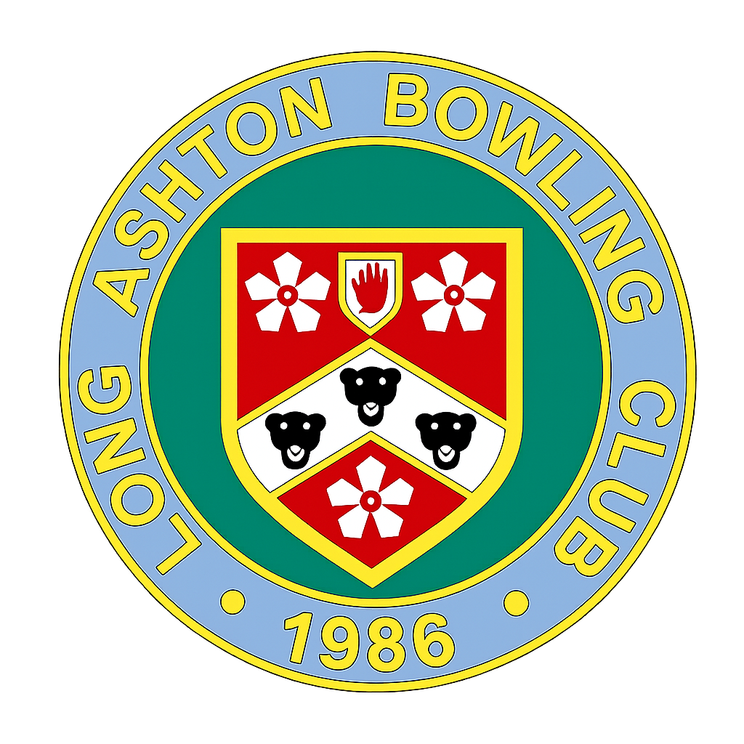

“The Bowler”

The Newsletter of Long Ashton Bowling Club
September 2026

Welcome to the new look.
Welcome to the first edition of The Bowler for many years, and what better time to relaunch our newsletter than as Long Ashton Bowling Club celebrates its 40th Anniversary.  Over the past four decades, much has changed. The club has grown and evolved, new friendships have been formed, and countless memorable moments have been shared on and off the green. While many things are different today than they were in 1986, one thing remains as important as ever: keeping our members connected, informed, and involved in club life.  That is the purpose of The Bowler.  We hope this newsletter will become a regular source of news and information for everyone in our club community. Each edition will be emailed to members, published on our website, and hard copies will be available in the clubhouse, ensuring that everyone can stay up to date in the way that suits them best.  In future editions, you can look forward to updates from our Captains and coaches, reports on our successes and challenges, news of social events, and information about developments around the club. We also hope to celebrate the achievements of our members and share the stories that make Long Ashton Bowls Club such a special place.  Of course, a newsletter can only be as interesting and engaging as the contributions it receives. This is your newsletter, and we would love to hear from you. If you have news to share, photographs, memories from years gone by, amusing anecdotes, or anything else that you think fellow members would enjoy reading, please do send it in.  As we celebrate our 40th Anniversary, this feels like the perfect opportunity to strengthen the connections that make our club so welcoming and successful. We look forward to working with you all and making The Bowler a newsletter that truly reflects the spirit of Long Ashton Bowls Club.  Happy reading, and here's to the next 40 years!  The Editorial Team |  | In this edition  President’s Musings.  From the Chair  Captains’ news.  Karen’s Column  Green Matters  Club News  Exchange and Mart  Social Life
“Don’t aspire to be the best on the team. Aspire to be the best for the team.”

Brian Tracy, Author

President’s Musings

It’s one evening and I am at my lap top working on the teams for the next short mat when I received a phone call. “Hello Peter” It’s Vernon Adams the Men’s President. “Would you be prepared to be the next President?”
Complete shock, it hadn’t even entered my head, surely, they can get someone better than me. Well, it certainly cannot be more work or take up more time than I encountered as the Over 55s Captain. Such thoughts quickly filled my head, and it was after all a great and quite unexpected honour. I thanked Vernon and said it was an honour and I was prepared to take it on. I was still a little in shock and never thought to ask Vernon what was involved. Ah well, there was always Google Search.
So, as Men’s President can I start by congratulating every one of you for making 2026, our 40th anniversary year, so successful. We welcomed 18 new members this year bringing our total to 126 thanks to Peter Wakely our publicity officer and from the resulting coaching activity. I was pleased to see so many new faces playing on a Friday evening and playing very well. We need you to help our club in 2027 by adding your name to the availability sheets for the various league matches.
Thinking of the leagues, we must thank Maurie Palmer-Givan for working flat out to fill the increased number of 5 rinks in the Clevedon Wednesday League. Again, this is where new members can be so beneficial by playing in the leagues. The ladies have had a great year with some amazing results, but I shall leave that to the Lady President.
There are so many people to thank that I dare not try to name them all individually as I am sure to miss someone. So, it has been a very successful year, and my thanks go to all the officers in the club, all the willing helpers who turn out on a regular basis, those looking after the green and the surrounding flower beds. And finally, on behalf of all the captains a great thank you for those who make themselves available to play matches on a regular basis.
As I am writing this, I am conscious that a meeting of the men has been arranged to decide on the future leagues’ situation. By the time you read this you will be aware of the result. As Men’s President, I really hope that a decision suitable to all male members will be the outcome.
Finally, I want to apologise for not taking part in many of the club’s internal competitions and therefore not getting to know you all. Unfortunately, my domestic situation restricts the amount of time I have available away from home.
Peter Silva

From the Chair: Malcolm Pemble
Wow, what a fantastic summer season we have had. The sun has shone, albeit too hot at times and the green has played really well. Just like our ladies, who must be congratulated on winning all 3 leagues in which they played. They truly are a force to be reckoned with.
The annual match against the Somerset Patrons was re-instated this year, and a wonderful afternoon was experienced by both sets of bowlers. The Don Radford Trophy was once again won by our mixed rinks, playing in the morning and the afternoon.
All of these successes added together mean that, thanks to you the members, we have had a memorable 40th Anniversary Celebration. Here’s to the 50^{th.}

View From the Bridge

“What a year for LA ladies!”
A great season for Long Ashton Ladies. We play in three leagues, the Bristol Evening League, the Doreen Ralph Trophy and the North Somerset Triples and have won them all! The BEL success means we will be promoted to division one.  In addition, we have taken part in three Cup competitions, the Fear, Southey and the Top Club with some good wins. Unfortunately, we were unable to defend our 2025 Fear Plate title this year as we won our first match and were therefore excluded. The Don Radford Trophy was another great win for the club. A joint venture with the Men’s team.  Some ladies have managed to fit in, and had success in, one day events hosted by local clubs as well as in County competitions. With Ladies and Mixed friendlies, it has certainly been a busy summer. In total we have had 30 ladies playing for us some of whom have only joined the club this year.  I would like to thank everyone for their support. The vice-captain and other captains, the selection team, the players and those providing the teas. Not forgetting the management committee and all the supporters we have in the club.  The future certainly looks bright for Long Ashton Ladies!  Pauline (Ladies Captain)  ------------------------------------------------------------------------------------  Doreen Ralph League 2026  Thank you to all our players this year — more than 25 of you — for making yourselves available and for keeping on top of the online polls. It really does make a difference.  It wasn’t the easiest season with the hot weather and the arbitration issues, but you all stuck together and delivered a fantastic league victory.  Proud of the whole squad. Roll-on 2027.  Urszula, (DRT Captain) |  |  | 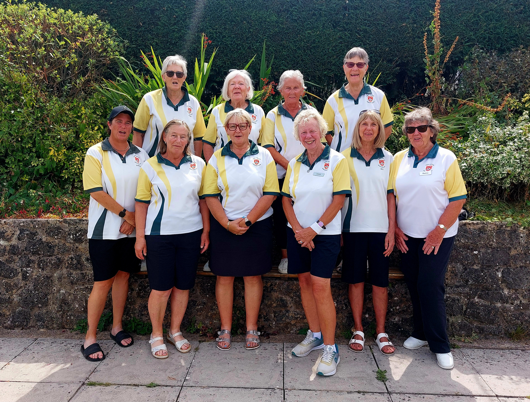  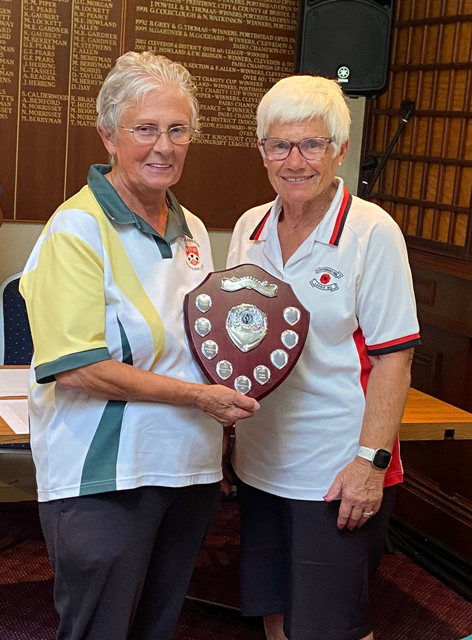

Karen’s Column: The Secretary’s view
This has been a very successful year for Long Ashton BC in more ways than one. Thanks to a productive recruitment campaign and the hard work of our dedicated team of coaches we have increased our membership by 18 new members, bringing the total membership to 126.
Most of the new members are full playing members and have enjoyed playing at Long Ashton BC whether having a roll-up, playing in the Friday evening umbrella or taking an active part in our league and friendly matches.
We hope to see more of you putting your names forward for the teams next season, as it makes our captains’ lives so much easier and enables you to improve your bowling and learn more about this great sport.
Whilst we have a dedicated band of members who not only play bowls but also contribute to the running of the club behind the scenes, we need more people to come forward to help.
I am sure many of you have skills and experience which could be put to good use to take this club into the future and continue the excellent work already being done. So please let us know about your hidden talents and become part of the “team”. We welcome your thoughts, ideas and suggestions to make this Club even better for everyone.
Karen Gough

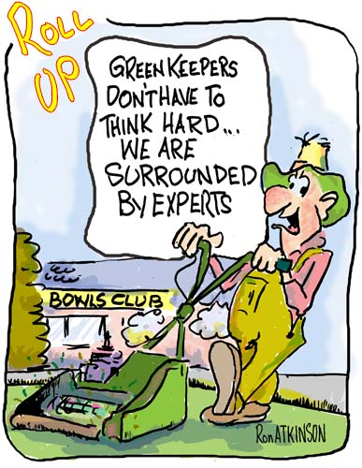
Green Matters

Updates from our green manager

“Maintaining the Green”

A good playing surface is essential, and the club’s contractor, Gareth, maintains the green throughout the season. He mows every Monday, Wednesday and Friday morning, which is why play starts after 10:30 on those days. Members are also asked not to play on Tuesday mornings to allow the club’s maintenance team to work. Gareth cuts diagonally to avoid creating runs and applies treatments to strengthen the grass, tackle pests and disease, and uses machinery to spike the surface for drainage and to reduce thatch buildup.
When the season ends, Gareth begins an intensive winter maintenance programme: scarifying (sometimes heavily), aerating, applying winter feed, analysing bore samples for nutrient needs, and surface dressing with a specialist and expensive bowling-green seed mix. This work must be done promptly so new seed can establish before temperatures drop.
Mowing continues through winter as needed because the grass often keeps growing; it is left longer than in summer, but still cut regularly to prevent moss. Club volunteers also sweep dew off the green every morning to help the surface dry and further reduce moss risk. More volunteers are welcome.
To spread wear evenly, rinks are moved frequently using velcro-attached markers. There are four settings when playing away from the pavilion and five across, allowing up to seven rinks when required. Rinks are moved after significant use, and direction changes happen roughly weekly. This year, more across-the-green play provided shade during hot spells. Over 50 moves have been made, and the green shows very little wear—an excellent foundation for winter work and next season.

Next time - The weather, watering & FAQs

Colin Ramsden

News

Portugal Bowling Holiday Interest
A small group of members is currently exploring the possibility of a bowling holiday to Portugal before the start of next season, likely in April. While no firm bookings have been made at this stage, places will be strictly limited if the trip goes ahead, as this is a pilot project but hope to extend the offer to more members in future, should it prove to be a success.
This could be a fantastic opportunity to enjoy some early-season bowling, good company, and warmer weather.
If this is something that appeals to you, please keep an eye on future club communications for updates and further details. Once plans are confirmed, members will be invited to register their interest and secure a place.

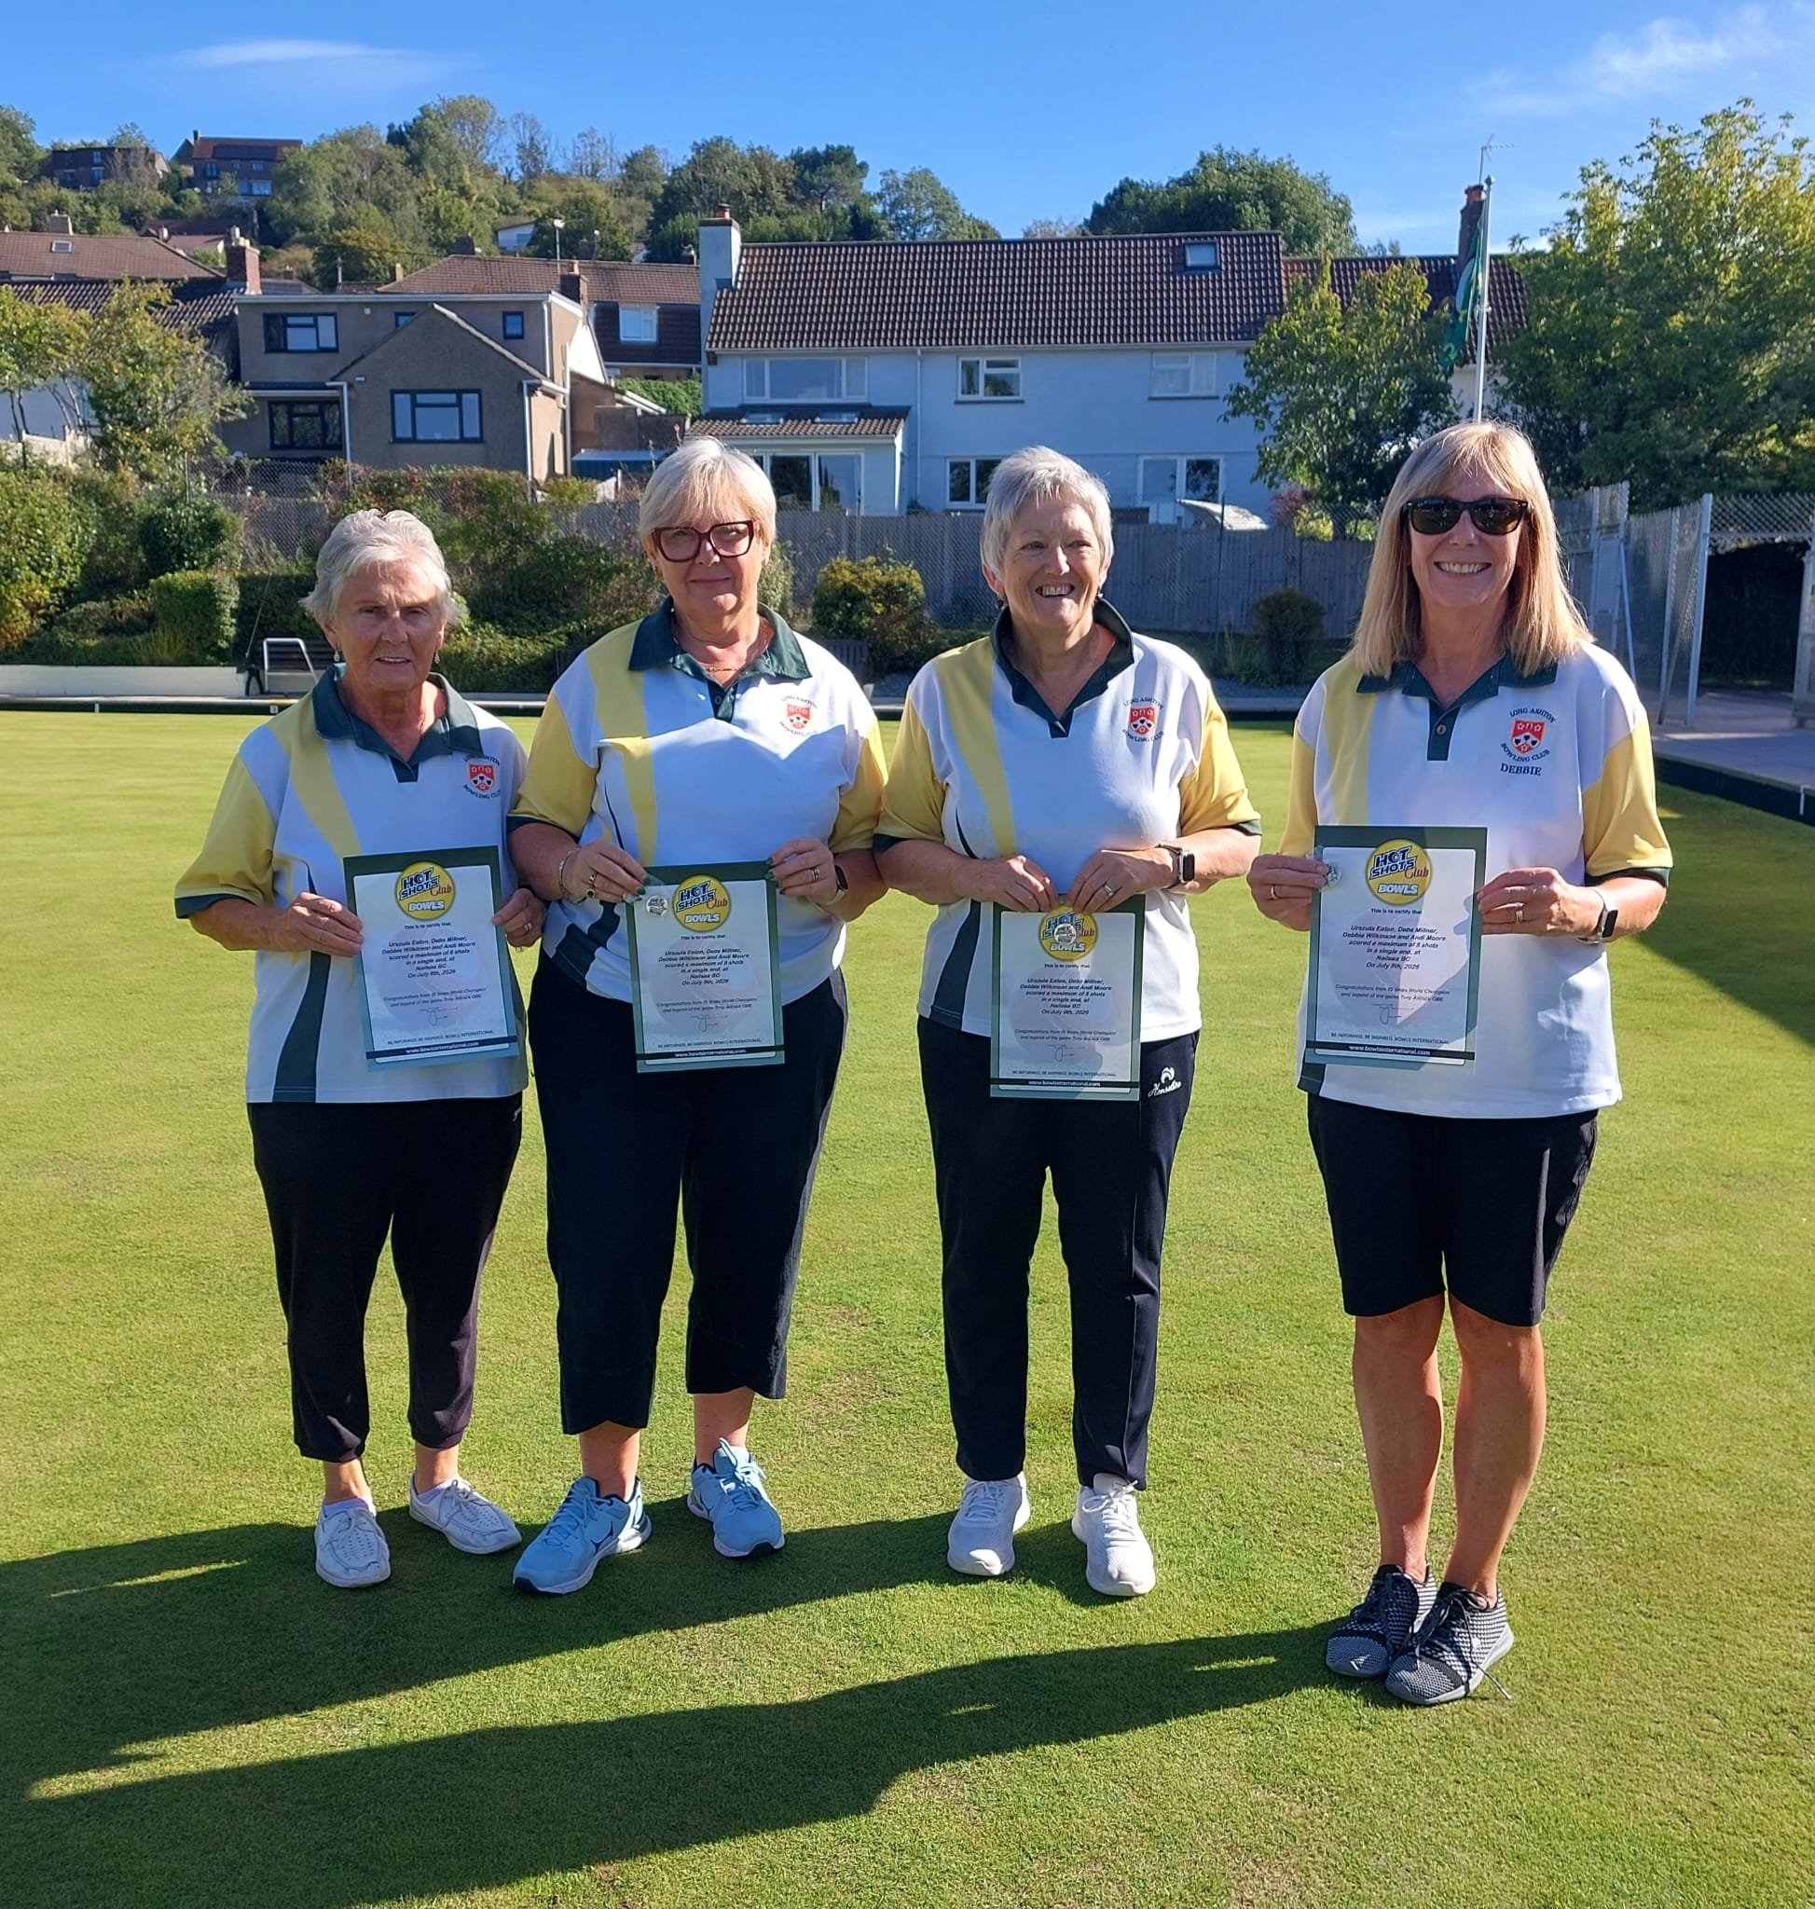
Hotshot Heroes
A quartet of Long Ashton bowlers are celebrating after receiving their certificates recognising the rare achievement of scoring a Hot Shot.

The impressive feat, which sees a team score the maximum 8 shots in a single end, was accomplished during their match against Nailsea in July.

Congratulations to Urszula, Deb, Andi and Debbie on this outstanding achievement.

Scoring a Hot Shot is a memorable moment in any bowler's career and a testament to both skill and teamwork.

Aussie Pairs
The club’s Australian Pairs took place on Sunday 6th September, with 36 players taking part. As the competitors arrived, they discovered who was to be their playing partner for the day. There then followed considerable speculation as to who would be the winning pair from each of the two groups.

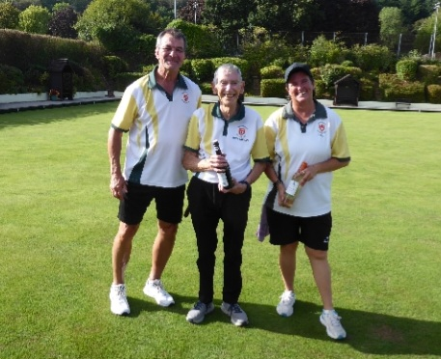
Of the 10 pairings who contested Group A, only the team of Sarah Buxton and Tony Latham achieved a clean sweep of three wins out of three, therefore securing their place in the final.

In Group B, 2 of the 8 teams scored the maximum 6 points from their three matches, so shot difference determined who would progress to the final. The unlucky pair who missed out were Liz Fox and Debbie Wilkinson, while Ann Haycock and Colin Ramsden were declared group winners with a positive shot difference of 19.

Spectators were treated to a close and exciting final in which Ann and Colin went into a narrow lead but were then pegged back so that the scores were tied going into the 6th and final end. With Sarah and Tony holding shot, Colin had the final bowl of the match. His weighted shot was bang on target, but when the woods and the jack came to rest, it was still one to Sarah and Tony.

An excellent final completed a thoroughly enjoyable day for all those involved.

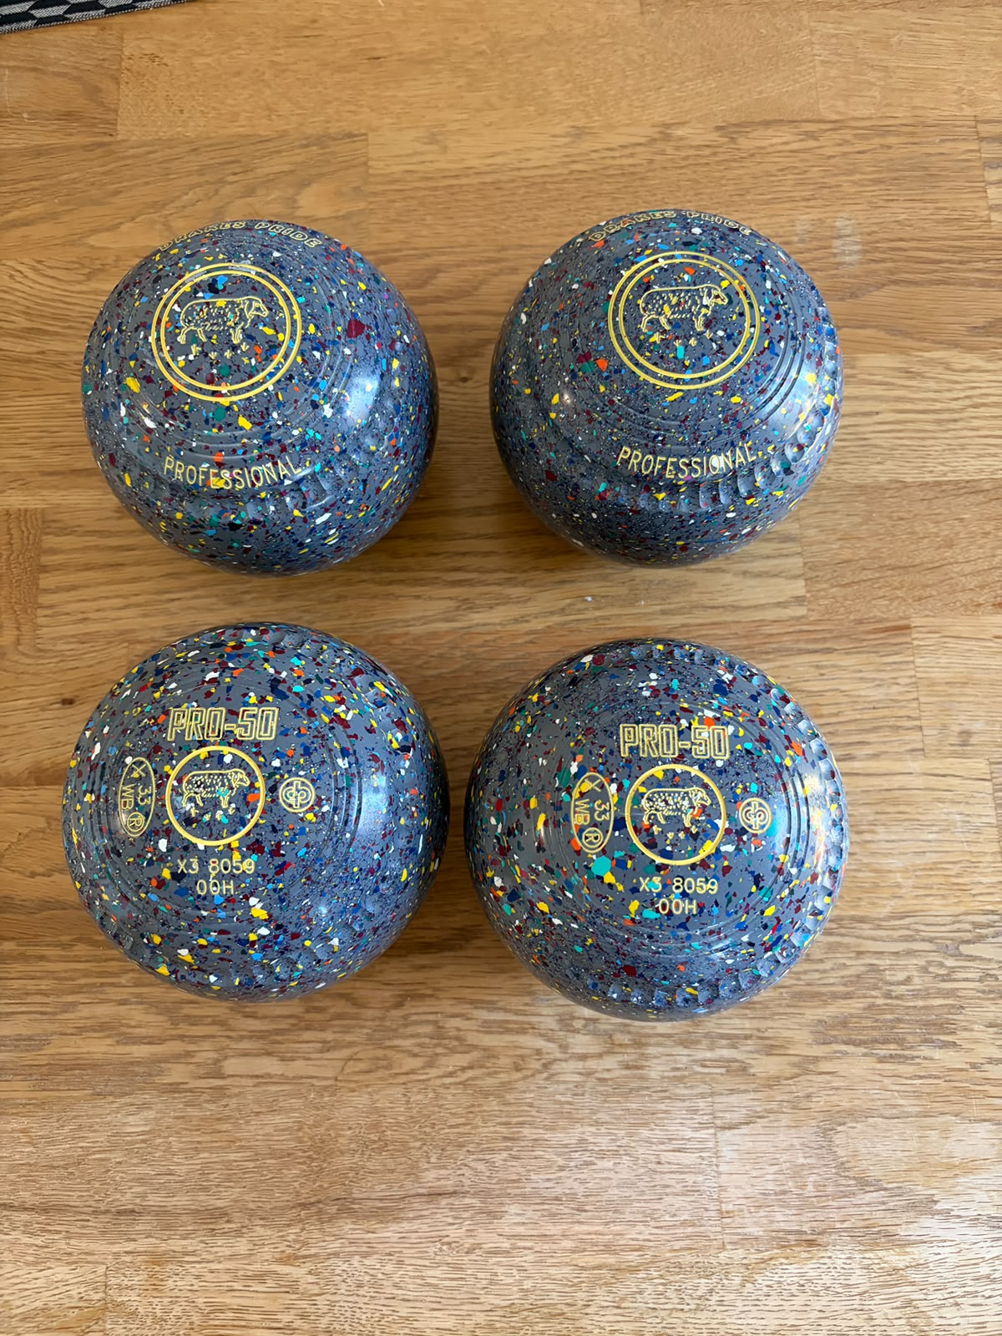
Exchange and Mart:

A great set of 4 nearly new woods. Drakes Pride Pro 50, size 00 in Grey Harlequin. Stamped 2033 but purchased in 2024. Used 1 season outdoors and 2 seasons indoors. No marks, scratches or damage. £300. Please contact Deb Millner. Tel. 07401094025

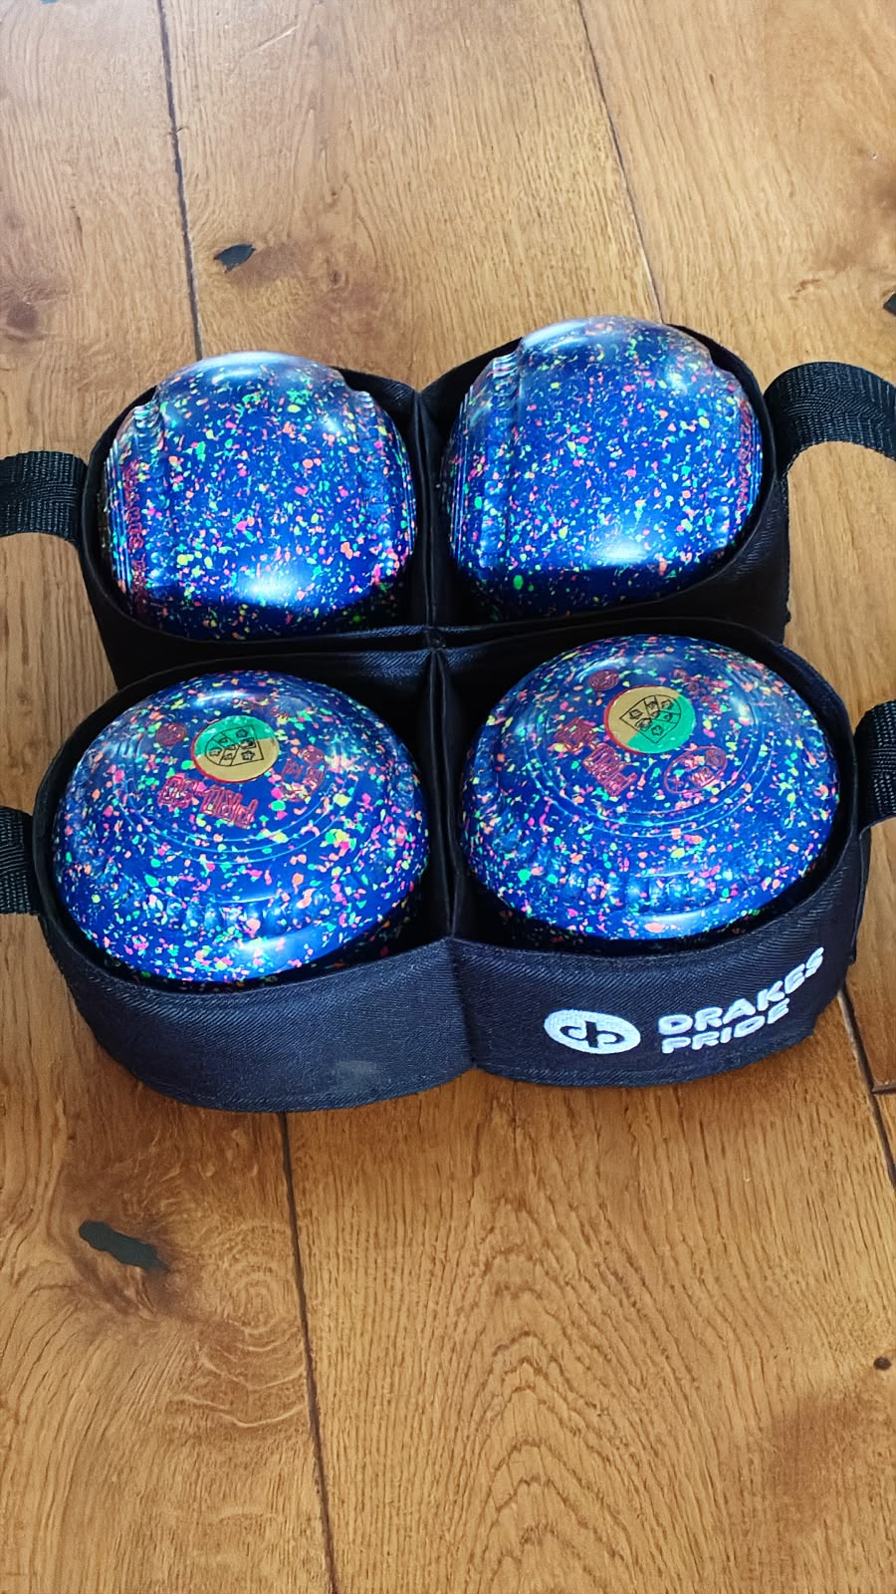

3 year old Drakes Pride Pro 50, size 2H, Stamped 2032. With carry case. £250. Please contact Kim on 07793072124

Social Life
This season our club organised a very successful community bowls day in May. It was very well supported by local businesses in the village and close neighbours. Rob and Liz at the Bird in Hand generously donated a keg of Thatchers – 88 pints – it was very impressive that the bowls club was then able to sell the cider during the day to raise money towards our Invitation 4’s prize money. However, the contents were mainly purchased by the team from the Bird!!!
Winter Socials
As always,
we look forward to our Winter Socials calendar – once a month on a Friday evening with food and entertainment. These socials are important to all members, a time to keep in touch, support and enjoy time together during the winter months.
In October we have a visit and talk by the Guide Dog Association.
Everyone is welcome to these evenings – look out for email information.
Greedy Goose - new members
Paul at the Greedy Goose at Gatcombe Farm has kindly supported our club this year by providing new members with
a £10 voucher off a Sunday lunch for 4 people. Don’t forget to use that voucher – sit back and enjoy the lunch.
Sandra P-G

Contacts:
Please, if you have anything you would like included, or suggestions for content, get in touch.
Peter and Sarah Wakely
longashtonbc@gmail.com

